Francisco Javier Diaz  Email: jdiaz@unlp.edu.ar  https://ar.linkedin.com/in/javier-diaz-1a07a212  https://www.linti.unlp.edu.ar/uploads/docs/cv_jd_marzo_2022.pdf  degrees obtained  Graduate in Applied Mathematics and Scientific Calculator  Faculty of Exact Sciences - National University of La Plata  TEACHING BACKGROUND  Full Professor “Security and Privacy in Networks” and “Advanced Concepts of Computer Security” and  “ Advanced Ethical, Social and Professional Aspects of Computer Science ”  Designated Extraordinary Professor in the Emeritus category from November 2023. | 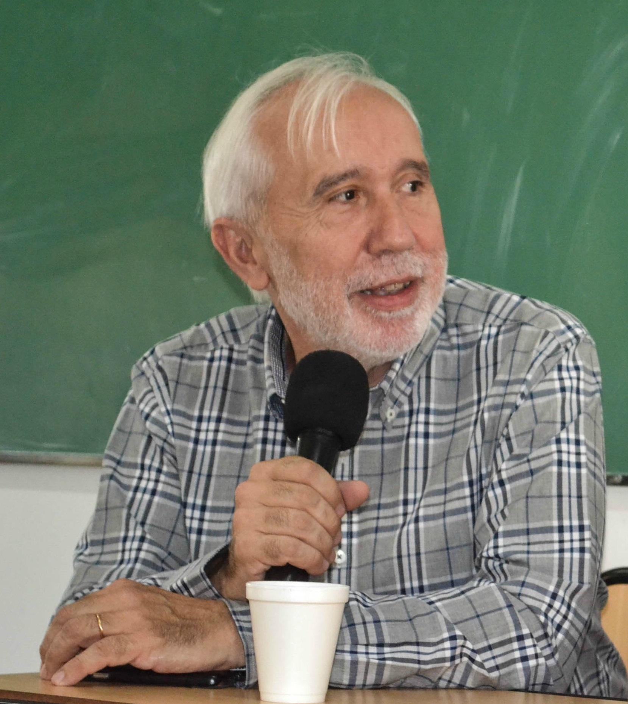
Activity and production in scientific research
Category I (maximum) of researcher teacher National Research Incentives Program:
Date: June 2005 and ratified in 2018
Centers and Laboratories
Founder and Director of the Laboratory of New Computer Technologies (LINTI) since its creation in 1995. The LINTI is a Research, Development, Extension, Innovation and Transfer Unit of the Faculty of Computer Science of this University, where 30 researchers, thesis students and scholarship holders work. under his direction.
https://linti.unlp.edu.ar/
General Scientific and Technical Director of the Information Processing Center (CESPI) since 1990. Where the different computer systems that provide services to all the communities of the National University of La Plata are designed, developed, maintained and managed. Among the main systems we can mention:
- Payroll system of the 14 thousand employees of the University and the online receipt system,
- Students enrollment and academic history management:
  - 8 thousand undergraduate students from the five pre-university schools and colleges
  - 123 thousand undergraduate students from all Faculties
  - 22 thousand postgraduate students from all Faculties
- the systems for administration and management in its different areas of the Presidency and Faculties serving 2 thousand employees,
- Servers for Internet name service, email, proxies, user authentication and Internet databases and the UNLP intranet. The 20 km Fiber optic network that links all the Faculties, colleges and institutes and research is managed and supervised.
https://www.cespi.unlp.edu.ar/
International Participation in Working Groups (Currently)
Group Coordinator Metared Argentina Cybersecurity and member of the International Cybersecurity Working Group. since 2019 and continuous
Coordinator of the ICT Nucleus of the Association of Universities Group Montevideo (AUGM) since 2010
Network of Excellence in Cybersecurity of Latin America and the Caribbean (Red CiberLAC), promoted by the IDB, member of the Board of Directors since December 2021
Contact point of the UNLP as an Academy associated with the International Telecommunications Union since 2014

BOOKS and Publications
He is co-author of ten (10) books on computer science topics and more than 200 magazine works,
book chapters and proceedings of national and international conferences. He has supervised 12 approved doctoral theses, more than 30 approved master's theses and final specialization projects, and more than 60 final degree dissertations in the computer science area.
Scientific publications see:
https://scholar.google.com/citations?hl=en&user=5nzFNBgAAAAJ
https://www.researchgate.net/profile/Javier-Diaz-4
https://orcid.org/0000-0002-4225-3829
http://sedici.unlp.edu.ar/browse?authority=http%3A%2F%2Fvoc.sedici.unlp.edu.ar%2Fnode%2F55039&type=author
Scopus number: 56533036700

Doctoral Thesis Supervised
"Computer audit method to minimize the risk of quality of results based on advanced data processing systems"
Author Daisy Imbaquingo Esparza PhD Computer Science UNLP 11Sept/23
“Hope Project: Augmented Reality for teaching-learning processes in children with ASD” Author Mónica Romero Pazmiño. Doctor in Computer Science. UNLP 2022-12-6
Modeling lage-scale scientific data transfers” Author Joaquín Bogado
Doctor in Computer Science. UNLP 2021-12-16
Analysis of online social networks as a safe communication environment for gerontological family-social inclusion" Author Ramiro Ríos Paredes
PhD in Computer Science. UNLP 6/7/2021
Optimization of energy consumption in mobile devices for use in isolated rural areas supplied with photovoltaic solar energy Author: Rocabado Moreno, Sergio Hernán . Doctor in Computer Science. July 30, 2020
Management Model for the Prevention of Money Laundering (PLA) in the gambling sector. Author: Lía Molinari. Doctorate in Administration Sciences. UNLP. Date: 2017
Study of the influence of a simulation environment in the teaching of computer networks at the university level Daniel Arias Figueroa. PhD in Computer Science UNLP. Date: 2017
Architecture of a Data Center with DevOps Tools. Author Belalcazar Villamar Pedro Alberto. PhD in Computer Science UNLP. Date: 2017
Protocols to Apply in Computer Forensics in the Framework of New Technologies (Expertise-Forensics and Cybercrime) Darío Piccirilli. Doctor in Computer Science UNLP. 2016
Contributions to modern functional verification Goñi, Oscar Enrique. PhD in Computer Science UNLP. Date: 2015
Contributions to the establishment of a global network of interconnected wireless sensors. Author: Sosa, Eduardo Omar. Doctor in Computer Science UNLP. 2011
Artificial Intelligence and Law: Some Epistemological Approaches to Normative Deduction and Case-Based Reasoning. Author: Clara Smith
Doctorate in Exact Sciences from the UNLP in March 2000.

POSITIONS IN UNIVERSITY MANAGEMENT
Dean of the Faculty of Informatics in three periods (1999-2001, 2004-2007, (2010-2014), Vice Dean of the aforementioned Faculty in two periods (2001-2004, 2005-2009), Secretary of Linkage and Technological Innovation of this University from 2018 to the present, Secretary of Institutional Relations (2014-2018), Academic Advisor of the Faculty of Exact Sciences (1989-1999), Head of the Computer Science Department of the Faculty of Exact Sciences (1995-1996), Coordinator Academic of the Computer Science Department of said Faculty (1996-1997), Coordinator of the Academic Networks Area of the Association of Universities Group Montevideo (2006-2007); who is the creator and Director of the Master's Degree in Data Networks and the Specialization in Networks and Security, both from the Faculty of Computer Science and Director of the Bachelor's Degree in Computer Science

